Exception Handling Middleware
This step is important to display meaningful error and to hide the database structure that will display when error happened.
This step also needed in production and large scale application so it really important
- Create file in Restaurants.Api/Middlewares/ErrorHandlingMiddleware.cs
  - Inject IMiddleware and implement missing member
  - Make the method as asynchronous
  - Setup try and catch exception in the method
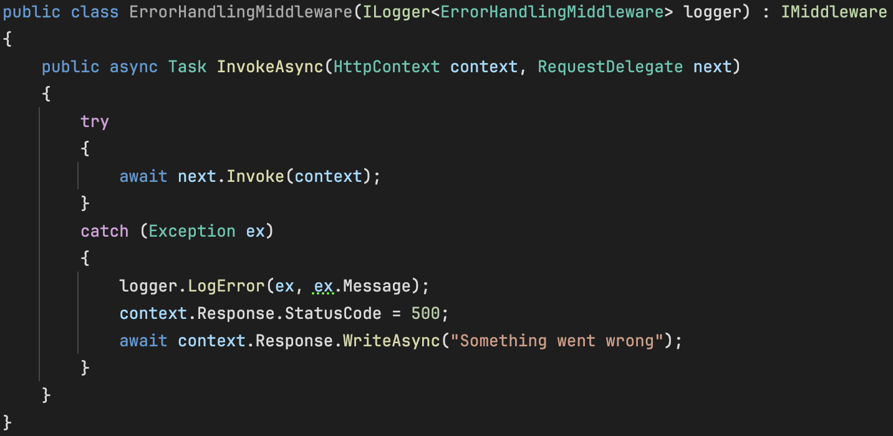
- Open program.cs to register error handling middleware and use it

- Test it
  - We open appsettings.Development.json
  - In our connection string just remove R for our database name
  - Run the application and we try to execute any API in swagger
  - Error will show as below
